Worksheet 1: KlimafolgenOnline-Bildung.de
Mean temperature
1. In your group find out how the daily mean temperature has changed over the years and will probably change. Take key notes and discuss your findings.
The picture on the right side shows the RCP 8.5 scenario with medium temperature increase.

1900–2000 2000–2100
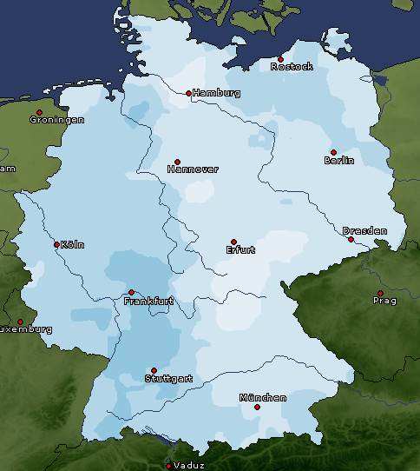 | 